Meeting Opened: | 7:00 pm | Meeting Closed: | 8:02 pm
Present: | 19 in attendance as per attendance spreadsheet
Apologies: | Linda M, Emma C, Chris A.

- Welcome and apologies
Apologies as per above
- New members
Ceridwen Pontello | Debbie Sandy
Alex Dembainy

- Review and acceptance of previous minutes
Minutes published here - Parents' and Citizens' Association - Narraweena Public School (nsw.gov.au)
Motion to accept:  Seconded: | Laura S  Frank V
- Correspondence In/Out
  - Correspondence In:
- None
  - Correspondence Out:
- None
- Presidents Update: Kate N
- Uniform shop has had the air conditioner installed. Thank you to all involved
- The polling system for the Christmas gift was successful.
- Parents are looking forward to visiting the classrooms tomorrow for Education Week.
- We are still always looking out for volunteers at the canteen and uniform shop. It would be good to get more people trained and involved. Thanks to those who are already volunteering.
- Reflecting on the good relationship that the community has with the school. Would like to acknowledge the good experience we have.
- Explore & Develop: Laura B
- Our Vacation Care program was lots of fun and overall, quite successful. It was great to see the children try new things and venture outside of the school grounds (Macquarie for ice-skating, Warriewood Cinemas). The new booking system on OWNA allowed for parents to go to a waitlist, where they were alerted instantly if anyone cancelled, this was utilised most days. Our parents have also been great at marking their children absent throughout the week for Before and After school care which has allowed for other families to book casually when needed.
- We have seen many sick staff and children over the last couple of months, thank you for being patient with us during this period. As this seems to be settling, we have started a Reading Club – where the OSHC children read to the long day care children in the afternoons. We commenced this, this week and the children have loved it, asking to do it every day! It is lovely to see these relationships blossom.
- Sabrina is currently finalising re-enrolments for Long Day Care, which is looking positive. Laura will be starting this process for OSHC in the coming weeks. There has been a lot of enquiries from new families who will be joining the school next year as well as current Explore and Develop families.
- The OSHC service will be losing a few staff members who are relocating, we are in the process of re-hiring so there will be some new faces around. All staff across both services have undergone recent food handling training, in line with current amendments to requirements.
- Sub-committee reports
  - Uniform Shop Report – Paula P
- We have an air-conditioner, thank you to all who were involved with getting that. It's great at warming up the place & I know it will be highly appreciated during the summer months, thank you.
- We are currently fully stocked on all uniforms.
- As always, a huge thank you to my volunteers!
- Ordered clear boxes to improve the packaging.
Motion to accept:  Seconded: | Jess M  Peta M
  - Canteen Report – Sarah C.
- All is going well in the canteen. End of term went great, busy right to the last minute.
- Canteen is now fully restocked and has started off strong in the first week back of term.
- This is the link for the canteen volunteers schedule https://signup.com/go/zNtadNy
- There are no Workplace Health and Safety issues to report.
Motion to accept:  Seconded: | Keitana M  Linda N
  - Band Report – Laura S
- Band report: Week 3 Term 3
  - Musical Minds workshop preparation going well, it will be on 26th and 27th August from 12.45-5pm concluding with a concert on the Sunday afternoon from 4-4.45pm. Thank you to the volunteers who have been supporting this.
  - Can we please confirm the school/P&C requirements for tutors/conductors/parents on site during weekend workshop including collection of WWCC, volunteer log etc. Requirements discussed:
    - Log for names in and out, including phone number. Required for both P&C and school requirements.
    - Parents need to have the volunteer WWC check and the school requires a copy prior to the event.
    - Kate B to ring the insurance to let them know about the activity.
    - Julie T will advise the Share our Spaces team.
  - New band equipment being investigated
  - String Ensemble & Training Band are playing at the Education Week concert
  - There is a concert to be held 4pm Sunday 20th August. This will be put in the newsletter.
Motion to accept:  Seconded: | Jazmin V  Micaela J
  - Fundraising Report – Micaela J.
FATHERS DAY – Friday 1st September
- Micaela to put a flyer on the gates, with a QR code for volunteer sign up
- Frank organised a quote for bacon, eggs, rolls, sausages and onions. Could do donuts etc. as a sweet option. Fundraising Committee to organise how to receive preferences for sweet/savoury to assist with catering.
- Bunnings are unable to support with plants again this year. Micaela is checking with the Warringah Mall store. Volunteer Committee will consider approaching Mitre 10 as an alternative.
- Sea Eagles are unable to support again also.
- Still seeking alternate coffee vans for father’s day as regular van will be on holidays - no luck yet

BOOKWEEK PARADE
- Book Week Parade, Wednesday 30th August - in the past we have provided a morning tea. To consider if we would want to do this again.
- Support from the school to have the coffee van at the parade if it is available

CHRISTMAS GIFTS
- There was good feedback from the survey. The plates received the most votes so have been chosen.
- We will require volunteers to help scanning in the artwork. Artwork is due back to the company by the 15th September. Allows for delivery of the plates to the school at start of December.
- Action: Miceala to speak with Julie T re next steps of communication for teaching staff and community

TRIVIA NIGHT
- There may not be enough capacity with volunteers to deliver this. Consider what the main purpose is? Fund raising or social connection? It would require a lot of effort to organise and perhaps may not be the greatest earner. Fundraising Committee to investigate if we could attend an existing trivia, with a capacity for around 250 people. Perhaps Dee Why Bowling Club or other local club. Action: Jess following up with DY Bowling Club to see if this is a viable option
- There were around 200 attendees at the last event - as per the hall capacity.
- We will revisit at the next meeting to see what volunteer numbers we have to form a sub committee to organise to the Trivia night, noting that it is a commitment of approx. 1 day a week
- Note that it can be hard to get good donation items.
- If anyone has other ideas please send them through
- Considered an adult disco - perhaps not something that would get a lot of support
- Dancing in the Dark - at Warriewood Community Centre is another option.
- The Garden Club are preparing a recipe book as part of their grant. We do not want to double up with this.

CHRISTMAS CAROLS
- The school will provide possible dates for the event. A date for the carols to be determined by the school. A Thursday could be a good option to avoid conflicts with other events. Proposed Date: Tuesday 12th December (Week 10)

  - Treasurers Report – Kate B
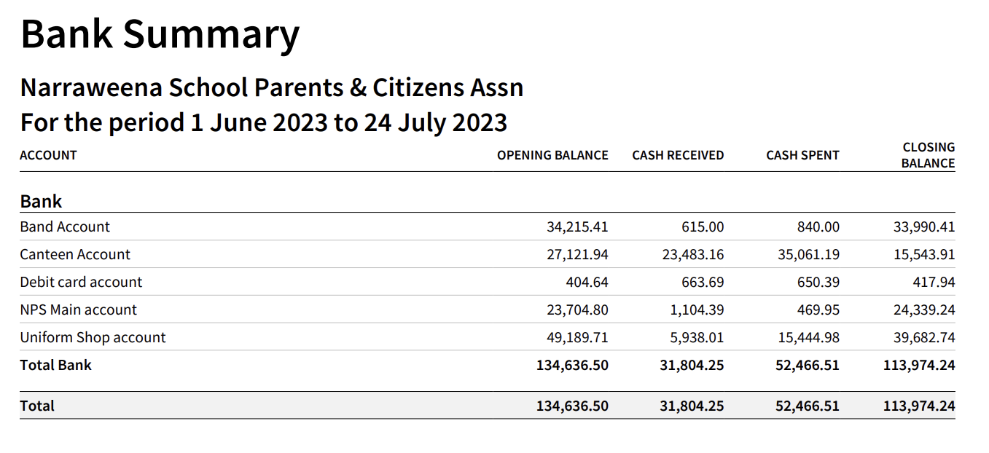
Since last P&C Meeting:
- Band:
  - Remainder of annual fees have been received and a conductor paid.
  - Need to send reminders to those who pay per term, term 3 fees due.
- Canteen:
  - The current account balance is low because of all the following large outflows:
    - Fridge repair and ultimate replacement paid just over $4,000
    - Q2 2023 PAYG and superannuation paid – note that superannuation has gone up to 11%
    - All invoices paid for term 2 supply purchases
- Uniform shop:
  - Sales went well in the last weeks of term, using Back-to-school vouchers before the offer finished 30 June 2023
  - Winter stock invoices paid
- Main acct:
  - Cash in:
    - iCare Workers insurance refund from wages calculation correction.
  - Cash out:
    - Mothers Day expenses – paper bags for the gifts – adjustment to P/L.

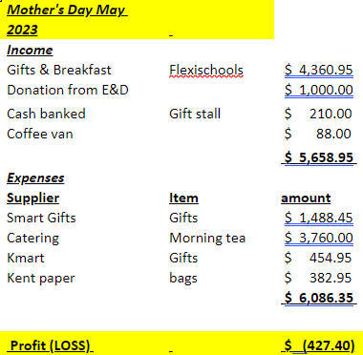

Motion to accept:  Seconded: | Jess M  Michelle F
- Principal’s Report – Julie T.
- Good to see everyone. Introduced Hannah Barnsley and Nancy Chaffer
- Thank you for mentioning WHS. It is important we continue to consider this in all activities.
- Looking forward to Education Week visitors
- NAPLAN results will have recently been received for Yr3 and 5 students. The scale used for assessment has recently been updated which makes it harder to compare the data to the previous results.
- PSSA uniforms - some of the kits are short of numbers, don’t have the right sizes etc. Rod Tuckerman is organising some replacements which is estimated to be around $4,000. Would the P&C be able to fund half of this, at around $2,000. Paula may be able to assist with finding a well priced uniform supplier. Members presented voted unanimously to support the purchasing of uniforms.
- Julie attended the Year 6 camp. Children were well behaved, and it was a fun, successful camp. This camp supports the Government subject unit. Thanks to the other teachers who attended.
- Staffing changes: Following the temporary to permanent industry changes some staff at Narraweena are in the process of being offered permanent roles. Gina Stanton’s position in the office has been temporarily filled by Nadine Fagen. The SLSO role is therefore being back filled. Chris Allum is moving to QLD will be leaving NPS at the end of next week. They are working hard on a replacement. An announcement will be made as soon as possible. His AP role will be permanently filled by Ria Sommerville, filled from the eligibility list. The Kindergarten AP role is being back filled through an internal expression of interest.
- The school is able to borrow STEM resources from the Department of Education. The school currently has 2 x 3D printers on loan until the end of the year. The IT committee at the school know how to use it. Students will soon try produce items for the phenome tubs to be used as ongoing school resources.
- The recent reading workshop was videoed and a link will be included in the newsletter.
- Good to hear the positive feedback from the P&C President earlier. Also a reminder that if there is an issue there is a complaint handling process which will be shared in the newsletter. It starts with your child’s teacher and follows the process. Working together on a solution is the best approach.
- Actions from last meeting:
- School hall stage curtains and spot lighting.  - The stage currently has a curtain that cannot be drawn with a damaged track. It is missing a 'valance' above the main curtain to hide the scaffolding also. A quote has been requested to repair and add valance.  - In addition if funds allow it would be a good idea to upgrade the lighting with spotlights so the stage can be well lit without the use of the main hall lighting overhead. There is a lighting bar already installed so this could be a simple upgrade to improve performances and ceremonies. |  | - Mark S has heard back from the company. They will come out again a re-quote.
- Still a couple of P&C Committee position nominees that need to join the P&C to finalise their appointment. |  | - Band Committee members paid today:  - Alex Dembiany  - Ceridwen Pontello  - Closed
- Auditor donation to the school in Lieu of fees – Kate B  - To be used on reading resources for the new way of teaching reading. Approx. $400 like last year.  - Kate to organise with Cara M. |  | - More decodable readers were bought  - Closed
- Music Lessons held on school grounds – Kate B  - Prior to COVID students in the bands were able to use the school to have their music lessons before, during and after school hours.  - Is this something we are able to reinstate?  - School is happy to have it start up again, preferably in the afternoons.  - Tutors can contact Nancy C. or Julie T. |  | - Lessons have commenced last Monday  - Closed
- Solar in Schools – Nicki C  - The Solar My School and related grants have been closed and no more are being accepted, so I didn't proceed with trying to fill out those application forms. I was told the NSW government is looking for new ways to roll solar out across all schools.  - I've heard that it would be beneficial to email Michael Regan's office and let him know we are interested and ask for his advice in the matter.  - I would like to do this and see what I can find out then bring that to the next meeting to discuss with yourself and Mrs Tourney.  - Not any current discussions around solar in the school. Julie is happy for Nicki to do what is needed to get the school on the table. |  | - No update
- General Business
- Chess club – Debbie S.
  - Could a chess club being established at lunchtimes.
  - Some students already play informally at lunch
  - Mark S has asked around and the Academy of Chess do lessons. This is a parent paid activity and as per music lessons the school could provide a space for this. Afternoons may be better for classroom availability. Enquiries to date determined that lessons could be provided for $12 per student/lesson, Mondays have been proposed. Debbie S to prepare a proposal and provide it to the school to consider.
- Michelle F was proposed to be the treasurer for the canteen.
Motion to accept:  Seconded: | Kate B  Jess M
Meeting closed 8:02pm

Meeting schedule
2023
August | P&C Meeting – 1st August 2023 at 7:00pm
September | P&C Meeting – 5th September 2023 at 7:00pm
October | P&C Meeting – 24th October 2023 at 7:00pm
November | P&C Meeting – 28th November 2023 at 7:00pm

Draft fundraising schedule – 2023
2023
February
March
April | Easter Raffle/Morning Tea
May | Mothers Day Stall/Breakfast
June
July
August
September | Fathers Day Stall/Breakfast
October
November
December | Christmas Carols

